Hands-on Model Calibration in R

Model Calibration Exercise

|  |  |
| --- | --- |
|  |  |
| Fernando Alarid-Escudero, PhD1  Eva A. Enns, MS, PhD1  M.G. Myriam Hunink, MD, PhD2,3  Hawre J. Jalal, MD, PhD4  Eline M. Krijkamp, MSc2  Petros Pechlivanoglou, PhD5 |  |

Acknowledgements and attribution

Citations:

1. Jalal H, Pechlivanoglou P, Krijkamp E, Alarid-Escudero F, Enns E, Hunink MG. An Overview of R in Health Decision Sciences. *Med Decis Making*. 2017; 37(3): 735-746.
2. Alarid-Escudero F, MacLehose RF, Peralta Y, Kuntz KM, Enns EA. Nonidentifiability in Model Calibration and Implications for Medical Decision Making. *Med Decis Making*. 2018;38(7):810-21

In collaboration of:

1 University of Minnesota School of Public Health, Minneapolis, MN, USA

2 Erasmus MC, Rotterdam, The Netherlands

3 Harvard T.H. Chan School of Public Health, Boston, USA

4 University of Pittsburgh Graduate School of Public Health, Pittsburgh, PA, USA

5 The Hospital for Sick Children, Toronto and University of Toronto, Toronto ON, Canada

C:\Users\478030\Downloads\logo-nihes.png



**© Copyright 2017, THE HOSPITAL FOR SICK CHILDREN AND THE COLLABORATING INSTITUTIONS. All rights reserved in Canada, the United States and worldwide. Copyright, trademarks, trade names and any and all associated intellectual property are exclusively owned by THE HOSPITAL FOR SICK CHILDREN and the collaborating institutions and may not be used, reproduced, modified, distributed or adapted without appropriate attribution.**

### Exercise: Calibration of a Sick-Sicker Model

In this exercise, we will calibrate a model of a hypothetical Sick-Sicker disease. A Markov model of the Sick-Sicker disease has been implemented using four health states: Healthy (H); two disease states, Sick (S1) and Sicker (S2); and Dead (D). A state transition diagram is shown in Figure 1. All individuals start in the Healthy state (H). Over time, healthy individuals may develop the disease and can progress to S1. Individuals in S1 can recover (return to state H), progress further to S2 or die. Once in S2, individuals cannot recover (i.e. cannot transition back to either S1 or H). Individuals in H have a baseline probability of death, while individuals in S1 and S2 have an increased mortality rate compared to healthy individuals, modeled as a hazard ratio applied to the baseline mortality rate.

Unfortunately, while we can identify those who are afflicted with the illness through obvious symptoms, we can’t easily distinguish those in the S1 state from the those in the S2 state. Thus, we can’t directly estimate state-specific mortality hazard ratios, nor do we know the transition probability of progressing from S1 to S2. We do have some idea of the plausible ranges for these unknown parameters; these ranges are listed in Table 1. All other model parameters are known and are also listed in Table 1.

There are three calibration targets to be used in this example: (1) observed survival of a cohort over time; (2) disease prevalence in a cohort over time; and (3) among sick patients (S1+S2), the proportion who are in the S1 state at three points in time. The first two targets came from an observational study of a typical cohort of individuals. The third target was obtained by subjecting ill patients to an invasive procedure which can determine disease stage but can’t be used routinely due to its invasiveness. The calibration target values are provided in the data file “SickSickerTargets.RData”, which contains a list with three data frames: Surv, Prev, and PropSick.

## Tasks

1. Use the R script “CalibrationTemplate_SickSicker.R” as a starting point to code the calibration of the SickSicker model using random search.
   * Load and plot the calibration target data stored in “SickSickerTargets.RData”.
   * Source the file, “Markov_Sick-Sicker – Function.R”, which contains the SickSicker model function, markov_sick_sicker(). This function takes in a vector of three parameters, c(p.S1S2, hr.S1, hr.S2), and returns model outputs corresponding to the calibration targets. Try using the model function and look at the output.
   * Implement the random search calibration, following the same procedure as in the 3-state model (modifying where necessary). Note that the SickSicker model needs to be calibrated to three different targets.
   * Explore the top-fitting input sets (e.g. top 10, top 100). To visualize the best-fitting sets, use the scatterplot3d() function. Type “?scatterplot3d” for function documentation.
2. Save a new copy of your SickSicker model calibration code. Change the implementation from random search to Nelder-Mead. Where do you need to make changes? Use the Nelder-Mead calibration of the 3-state model as a guide.
3. Save a new copy of your SickSicker model calibration code. Use the Bayesian calibration of the 3-state model as a guide and modify your SickSicker calibration code to implement the IMIS calibration method.

#### Table 1: Input parameters

|  |  |  |
| --- | --- | --- |
| **Parameters** | **Variable Name in R** | **Value** |
| Time horizon | n.t | 30 years |
| Cycle length |  | 1 year |
| Names of health states (*n*) | v.n | Healthy, Sick, Sicker, Dead |
| Annual discount rate | d.r | 3% |
| Annual transition probabilities |  |  |
| Disease onset (Η to S1) | p.HS1 | 0.15 |
| Recovery (S1 to Η) | p.S1H | 0.5 |
| .....Disease progression (S1 to S2) | p.S1S2 | To be calibrated; range: 0.01 - 0.50 |
| Annual probability of death |  |  |
| Healthy to Dead | p.HD | 0.005 |
| Hazard ratio of death in S1 vs healthy | hr.S1 | To be calibrated;  range: 1.0 - 4.5 |
| Hazard ratio of death in S2 vs healthy | hr.S2 | To be calibrated;  range: 5 - 15 |
| Annual costs |  |  |
| Healthy individuals | c.H | $2000 |
| Sick individuals in S1 | c.S1 | $4000 |
| Sick individuals in S2 | c.S2 | $15000 |
| Additional annual treatment cost per sick individual (S1 and S2) | c.Trt | $12000 |
| Utility weights |  |  |
| Healthy individuals | u.H | 1.00 |
| Sick individuals in S1 | u.S1 | 0.75 |
| Sick individuals in S2 | u.S2 | 0.50 |
| Intervention effect |  |  |
| Utility for treated individuals in S1 | u.Trt | 0.95 |

#### Figure 1: Schematic representation of the Sick-Sicker model

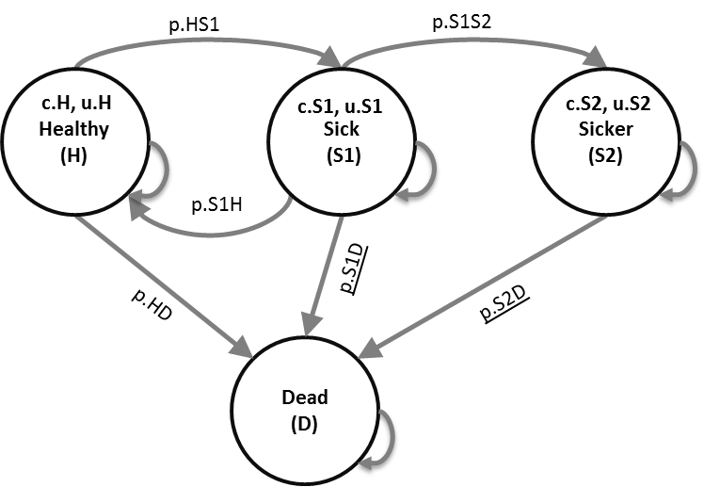

**Results**